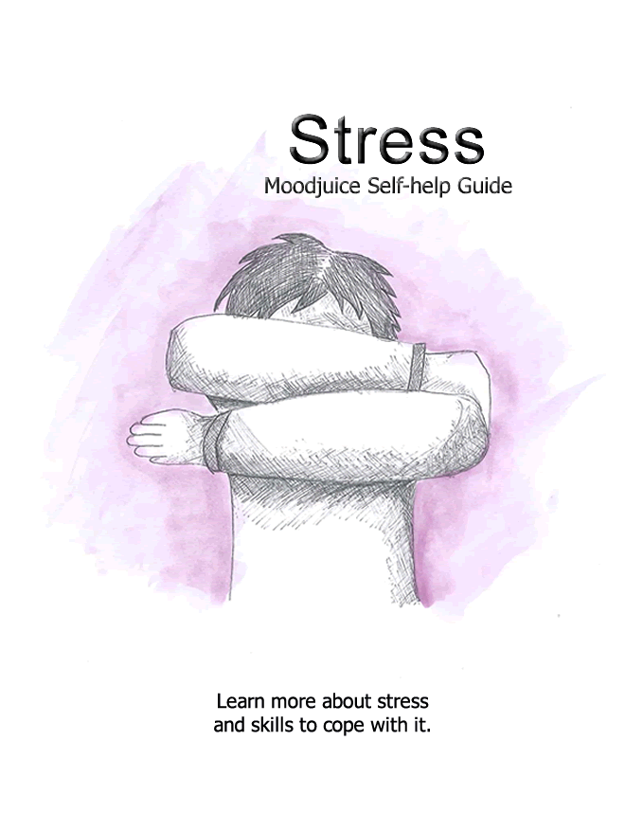

**Self Help for Stress**

* Do you find it a struggle to cope with the demands of everyday life?
* Do you feel like there is too much being demanded of you?
* Do you feel overwhelmed and unable to manage everything required of you?

If the answer to any of these questions is 'yes,' you may be experiencing symptoms of stress and you may find this workbook helpful.

This workbook aims to help you to:

* Recognise whether you may be experiencing symptoms of stress.
* Understand what stress is, what causes it and what keeps it going.
* Find ways to understand, manage or overcome your stress.

**Contents of this Self Help Guide**

Strategies that you could use to overcome your stress:

1. Understanding more about stress.
2. Learning how to challenge your unhelpful thoughts and see things in a more realistic light.
3. Learning how you can feel more relaxed, both physically and mentally.
4. Improving your problem solving skills.

When going through this booklet it might be helpful to try out each strategy one at a time, rather than trying to learn them all at once. However, simply take things at your own pace.

**Do I have symptoms of stress?**

If you experience symptoms of stress it is likely that you will recognise many of the feelings, physical symptoms, thoughts and behaviour patterns described below.

*Please tick which regularly apply to you.*

|  |  |
| --- | --- |
| Maskicon.jpg  **Feelings**  Tense Irritable Overwhelmed / Helpless Anxious | Manicon.jpg  **Physical Symptoms**  Butterflies in stomach Tired / Exhausted Light headed Nausea Poor concentration Disturbed sleep |
| iconps2a.jpg  **Thoughts**  I won't be able to cope There's no way I'll be able to manage all this I'm going to end up missing something I'm losing control | Walkicon.jpg  **Behaviour Patterns**  Being busy non-stop Easily irritated Finding it difficult to concentrate Being easily distracted Procrastinating |

If you have ticked a number of these boxes it is possible that you are experiencing symptoms of stress. However don't be alarmed, this is a common problem that can be overcome. By following the steps in this workbook, you may be able to learn how to improve your situation.

**What is stress?**

Stress is a feeling that we get when struggling to cope with the pressures of life. It can effect people in different ways. What may be stressful for one person may not be for another. Difficult life events or situations can cause a lot of stress. You might feel stressed if you don't have confidence in your own ability to cope.

Stress is a commonly experienced problem. You are likely to know others who have been in a similar situation. There is no need to feel embarrassed or concerned about stress. Often it can help to tell others about how you feel stressed. They may be able to offer helpful advice and support. Stress is not harmful in itself. You are not weak because you struggle with it. Stress over a long period of time can, however, make us more vulnerable to health problems.

Physical feelings are experienced when your body reacts to stress, fear or anxiety. These symptoms are often referred to as the 'fight or flight' response. This reaction quickly and helpfully prepares the body for action. It prepares us to either protect against or escape danger.

* Making our heart beat faster - to supply more blood to our muscles.
* Producing more sweat - to cool us down.
* Tensing our muscles - getting them ready for action.
* Taking deeper and quicker breaths - to supply oxygen to our muscles.
* Shutting down body functions that aren't needed at the time e.g. digestion.
* Racing thoughts - quickly narrowing the available options to make a quick response.

In the past such a reaction would have offered us some protection. Preparing us to react quickly in case of predators, and aiding survival as we hunted and gathered food. These days we do not depend so much upon running or fighting as we negotiate difficult circumstances. The symptoms described above are therefore less helpful. They may even end up being quite confusing. Threats like money problems, difficulties at work, unhelpful staff or rude drivers do not require such an extreme physical reaction. These symptoms are not dangerous in themselves. In many ways it is a useful response, but at the wrong time. We need not fear the fight or flight reaction. It is our body's healthy protection system. Understanding this can help you to manage the physical symptoms. You need not worry about them or feel that you need to respond or react. You can allow them to pass, as they will do quite quickly.

**What causes stress?**

**Life Events:**

Particular life events can cause people significant problems with stress. Difficulties that were previously manageable might also become much more challenging to cope with. For example:

* Being unemployed or losing a job
* Divorce or family turmoil
* Death of a relative or close friend
* Health problems
* Getting married
* Having a baby
* Starting a new job
* Financial difficulties (eg debt)
* Neighbourhood problems (eg noise)

**Thinking Styles:**

Stress can make some people feel anxious and low. This can impact how we think about ourselves and other people. We are more likely to think negatively about a situation. It is also common to feel that you are unable to cope. You might think that what is being demanded of you outweighs your ability to manage.

**Behavioural Explanations:**

You may find that you have developed strategies to avoid or escape situations in which you feel stressed. Such a pattern of behaviour may not be realistic or sustainable as a solution. In fact, this can make things worse.

**Biological Reasons:**

There may be some traits that biologically predispose individuals to experience more stress than others. For example, a high concentration of the stress hormone 'cortisol'. Over a period of time this can weaken your immune system. Such findings do not however mean that you can't do something about the difficulties that you are experiencing.

In reality it is likely that a combination of all these factors influence someone's stress. However, in some ways it is less important to know what causes stress, and more important to know what stops us moving past it.

**What keeps stress going?**

Many people who are stressed avoid people, places or situations that they associate with stress. Avoiding problems rather than facing them can make things worse. For example, not replying to communications from friends.

Stress may build up due to factors that are outwith your control. On the other hand, you might have developed a habit of taking on too much work. You may not feel confident saying 'no' when you are asked to take on new projects. There may be things that we can do to manage situations and prevent the stress from getting worse. Take stock of what is demanded of you. Try to realistically assess your ability to cope with these things. It may be possible to rebalance your commitments. Taking practical steps like this can help to resolve at least some of the stress that you experience.

When looking more closely at what stops us overcoming stress, it becomes clear that our behaviour, thoughts, feelings and physical sensations all interact and combine to keep our stress going.

**Understanding your stress**

Have a look at some of the examples and try to fill in something of your experience. See if you can recognise a similar pattern occurring within yourself.

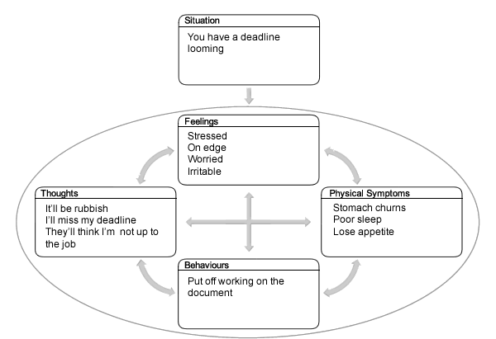

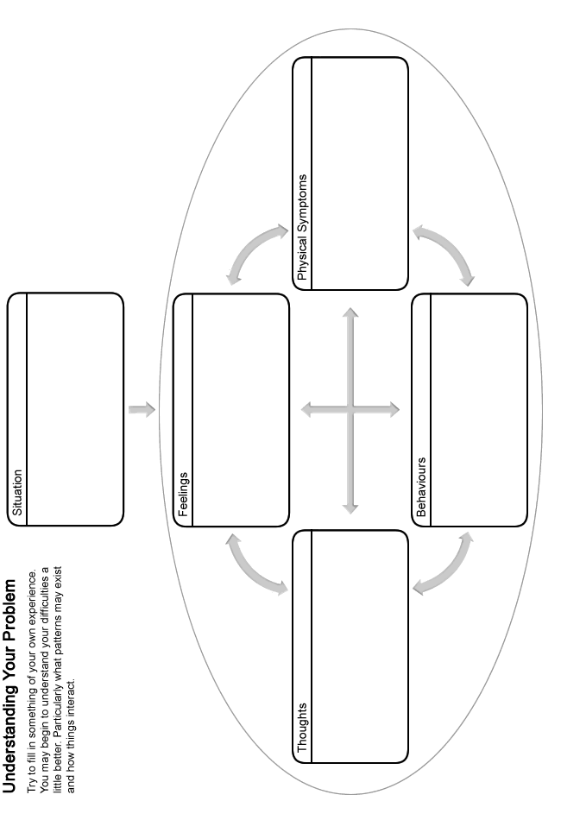

**How have you been coping so far?**

You may have been dealing with at least some of these difficulties for a while already. Think about what you've done so far to cope, and how effective these strategies have been.

* Will it be helpful in the long-term, or is it possible that they might be keeping your difficulties going? For example:
  + Working harder and for longer hours in order to get more done, but then taking on more projects.
* Think about how you might have coped well with difficulties in the past.
* What is going well currently and what you are doing to achieve that?
* What coping strategies and support do you have available to you? Could you be making better use of these?
  + **Social support** - speaking to people; family, friends, relatives, colleagues, etc.
  + **Confidence** - being sure of your own ability to cope.
  + **Problem solving** - being able to work out solutions to problems.
  + **Self-awareness** - knowing how this problem effects you; your body, thoughts, feelings and behaviours.
  + **Looking after yourself** - making sure that you have some time to yourself. For example going for walks, having a relaxing bath, etc.

**Challenging unhelpful thoughts**

The way that we think about things has an impact on our stress levels. Many of these thoughts occur outside of our control, and can be negative or unhelpful. It is therefore important to remember that they are just thoughts, without any real basis, and are not necessarily facts. Even though we may believe a lot of our unhelpful thoughts when we are feeling stressed, it is good to remember that they should be questioned as they are often based on wrong assumptions.

The following section will help you begin to recognise if you are thinking about things in an unhelpful or unrealistic way, and discuss how you can start to make changes to this. By doing so, you can learn to see things in a more realistic light which can help to improve your mood and reduce y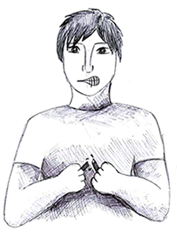our stress levels. You might have unhelpful thoughts about all kinds of things. Here are some examples:

About Yourself / Your Actions and Thoughts:

* I'm not able to cope
* I'm weak because I can't manage
* I can't do anything more
* I don't feel like I have any control

About the Future:

* I don't see an end to this
* I'm destined to fail
* What if I lose my job?

It is clear to see how this kind of thinking might bring your mood and confidence levels down. Do you ever think in any of the ways outlined above? Fill in your examples below:



You might find it difficult to identify an unhelpful thought. Try thinking about a time when you felt particularly stressed. Consider what was running through your mind at that time.

**Patterns of unhelpful thinking**

First you need to be able to recognise an unhelpful thought. Then you can challenge it. Being aware of the common patterns that unhelpful thoughts follow can help you to recognise when you have them. Here are some of the common patterns that our unhelpful thoughts follow:

|  |  |
| --- | --- |
| **Predicting the future**  **Catastrophising**  **What if?** | When people are worried about something it is common for them to spend a lot of time ruminating. You can end up thinking about the future and predicting what might go wrong. This is instead of just letting things be. You might blow things out of proportion, or come to expect a catastrophe. For example:   * What if my boss realises that I'm struggling? * What if I lose my job? |
| **Jumping to conclusions**  **Taking things personally**  **Mind reading** | When people are feeling emotionally vulnerable, it is likely that they take things to heart and become more sensitive to what people say. They can often make assumptions about why someone said something, beign overly quick to draw conclusions, and thinking that they are the focus of what has been said. For example:   * My boss will start asking questions if I ring in sick. * He's not rung back - he must dislike me. |
| **Focusing on the negative**  **Ignoring the positive**  **Filtering** | Often people can ignore the positive aspects of life or their situation. Instead you may focus on negative elements. This style of thinking stops us feeling good about ourselves. It can lower your confidence. For example:   * We could ignore the fact that we have many friends and focus on the one person that doesn't seem to like us. * We may give ourselves a hard time over something we are bad at (e.g. sports) and forget all the positive skills and qualities we do have. |
| **Black & white thinking**  **All or nothing**  **Perfectionism**  **"Should" thinking** | Sometimes people only see things as black or white, with no grey area or in-between. Having this polarised view can lead some people into setting themselves impossibly high standards, being overly critical and struggling to recognise any achievement due to their perfectionism.   * That was a complete waste of time. * They must hate me. * I should always get full marks. |
| **Over-generalising**  **Labelling** | Based on one isolated incident you might assume that other events will follow a similar pattern in the future. You might find it hard to see a negative event as a one-off. This can also mean that you label yourself, often unkindly, which can lower your mood and confidence, perhaps even leading to feelings of hopelessness. For example:   * Failing my driving test means I'll fail at everything. * The neighbour's dog snarled at me, all dogs are vicious! * I'm useless |

Do any of your unhelpful thoughts follow some of these patterns? Write down any examples you can think of into the box below:

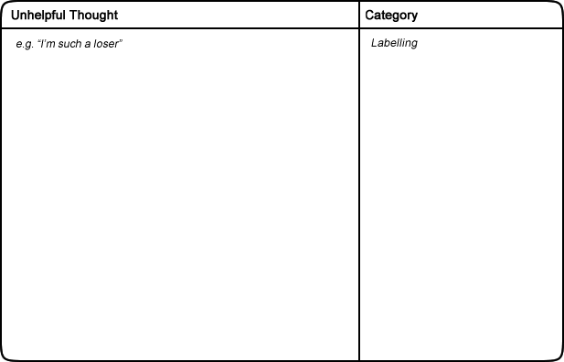

We can learn techniques to challenge these unhelpful thoughts. This can help to improve your mood and reduce your stress levels. The next part of this handout will discuss how we can go about challenging our unhelpful thoughts. You may come up with a more balanced thought that is accurate and based on evidence.

**How to challenge unhelpful thoughts**

Once you have recognised an unhelpful thought the next stage is to challenge it. To do this, you can ask yourself a serious of questions. See the example below:

*Situation: Deadline approaching for piece of work.*

arrowDown.png

*How you feel: Overwhelmed, irritable, on edge, worried, angry.*

*Unhelpful thought: I should have started this work sooner. I'll never finish it in time!*

**Challenges to an unhelpful thought**

Now you can challenge your unhelpful thoughts by asking these questions.

**Is there any evidence that contradicts this thought?**

* I've always done a good job of my work before.
* I've met deadlines well in the past.

**Can you identify any of the patterns of unhelpful thinking described earlier?**

* Catastrophising.
* Should thinking.

**What would you say to a friend who had this thought in a similar situation?**

* You still have time, just plan how to use your time best and get your head down.

**What are the costs and benefits of thinking in this way?**

* Costs: I am likely to distract myself from getting the work done. It makes me anxious before I even start the wiconps3a.jpgork. It puts me under even more pressure.
* Benefits: I can't think of any.

**How will you feel about this in 6 months time?**

* I'll probably look back and laugh about how silly I was being.

**Is there another way of looking at this situation?**

* I've always met deadlines in the past so I should be OK. I can only try my best. If I miss the deadline then I can just send the work as soon as it is finished.

Once you have asked yourself these questions, you should read through your answers. Try to come up with a more balanced or rational view. For example:

*I have met deadlines in the past and I am good at working quickly. I have plenty of time if I carefully plan what I need to achieve.*

Try to apply these questions to the unhelpful thoughts that you notice. It can help to improve your mood and reduce your stress levels. You can use this technique to test your thoughts are realistic and balanced.

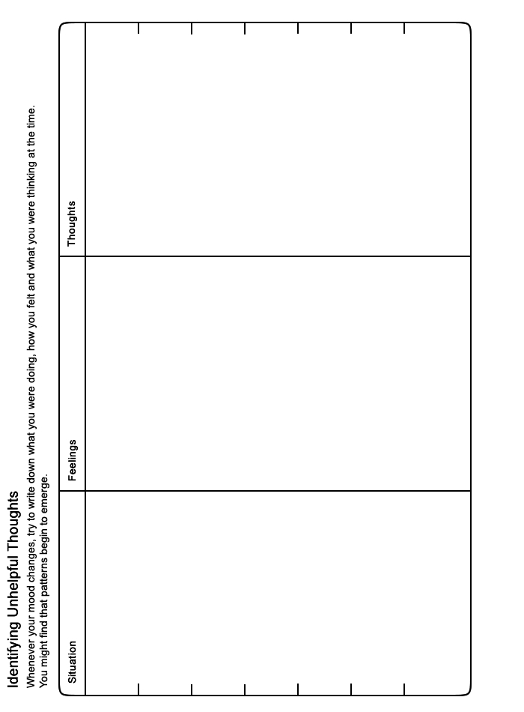

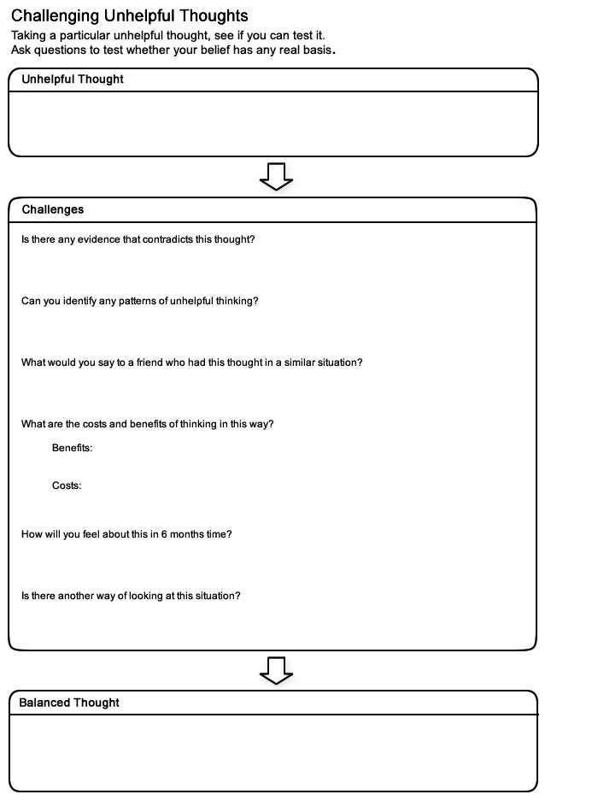

**Relaxation**

It is important to make time to relax and do activities that are enjoyable. This can help to improve your mood and reduce your stress levels by calming the body and mind. It can also help you to sleep. Without taking the time to unwind, it is easy to feel overwhelmed and stressed.

Relaxation can involve doing something that you enjoy, or just being by yourself. Good examples might be reading a book or having a bath. Exercise is also particularly effective at helping us to relax. What you do does not really matter. Try to choose something that you will look forward to and that gives you a break. Doing an activity that you enjoy will also give you less time to spend worrying. Here are a list of activities that might help you to relax.

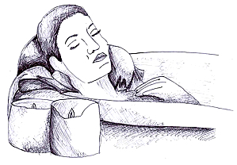

Suggestions:

* Do some exercise (e.g. swim, cycle)
* Read a book
* Go to the cinema
* Do something creative (e.g. draw, paint)
* Visit a friend or family member
* Have a bath

Try to add some of your own ideas into the box below. You will know what works best for you.



Try to find time to relax every day. This might seem difficult, but it is worth making time for. It can help you to feel a lot better. There are audio relaxation guides available that you might find a helpful support.

There are also some exercises described in the next few pages. They are specifically designed to help you to relax. However, you should stop the exercise if at any time you begin to experience discomfort or pain.

**Controlled breathing**

This simple technique involves focusing on and slowing down our breathing patterns. Many people find this simple exercise very relaxing. It can be particularly helpful for those who feel dizzy or light headed when they feel worried or stressed. This sometimes happens because people's breathing changes and gets quicker when they feel distressed.

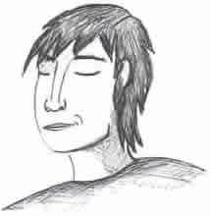

This can be an uncomfortable and unpleasant experience. It can make people even more on edge, and a vicious cycle can occur. Learning controlled breathing exercises can help you to manage these feelings more effectively. It can also help to give your mind and body a chance to calm down.

Remember, you can use this exercise to help you relax at any time. You could even use it to help you get off to sleep. However, it is particularly useful if you ever feel light-headed, dizzy or faint.

**Beginning**

Get into a comfortable position.

**Middle**

Work out a stable breathing rhythm. Perhaps try to breathe in for three seconds, hold this breathe for two seconds, and then breathe out for three seconds. It can be helpful to count as you do this (e.g. IN: 1-2-3, HOLD: 1-2, OUT: 1-2-3, HOLD: 1-2).

**Ending**

Repeat this action for a few minutes. You should soon begin to feel more relaxed. If you were feeling dizzy then this should also get better after a few minutes.

**Muscular relaxation**

Tension often builds up when we feel upset or stressed. These symptoms can be painful and can cause anxiety in themselves. Muscular relaxation exercises can help you to control such unpleasant symptoms. They can reduce physical tension and help you to relax in general.

During this exercise you have to tense and then relax different muscles in your body. You should focus on the feelings that you experience whilst doing this. With practice you will then be more able to recognise and respond to the onset of tension.

You can work through as many muscle groups as you like. Don't feel that you have to cover every muscle in your whole body. It can be helpful to stick to the same muscle groups each time you practice. That way you can get into a routine which you can easily remember. If you practice this nearly every day you will probably notice an improvement after a couple of weeks.

**Beginning**

Find somewhere comfortable and quiet where you won't be interrupted. You can either sit or lie down to practice this exercise. Begin by focusing on your breathing. Try to have a slow and comfortable pace. You could use the controlled breathing technique described earlier. Do this for a few minutes to prepare for the muscular relaxation exercise.

**Middle**

Try to tense each muscle group for around five seconds. Don't tense the muscle too tight. Focus on the sensations that this brings. Then relax your muscles for a similar length of time, and again, focus on how this feels. Then move onto the next muscle group. Try to remember to keep your breathing at a comfortable pace throughout. Below are some suggestions of muscle groups that you may wish to work through:

* Legs - point your toes and tense your muscles as if you were trying to stand up.
* Stomach - tense your stomach muscles.
* Arms - make fists and tense your muscles as if you were trying to lift something.
* Shoulders - shrug your shoulders. Lift them up towards your ears.
* Face - make a frowning expression. Squeeze your eyes shut and screw up your nose. Clench your teeth.

**Ending**

It can be helpful to spend a few minutes just lying quietly in a relaxed state. See if you can notice any tension in your body and try to relax it. Otherwise, just let the tension be. If your mind wanders, try to bring your concentration back to your breathing.

Finally, count down silently and slowly: 5-4-3-2-1-0, and come out of the relaxation in your own time. See if it's possible to carry that relaxed feeling into whatever you do next.

**Distraction**

Distraction is a good technique to fend off symptoms of anxiety and stress when they feel overwhelming. This can also give you space to deal with a situation in a more considered and positive manner. It is also helpful when you don't have the space or time to use a more proactive approach, such as a relaxation exercise.

Distraction simply involves trying to take your mind off uncomfortable symptoms or thoughts. You can do this by trying to focus on something unrelated. Often this helps them to pass. It is still important to remember that the symptoms of anxiety are not harmful or dangerous. Even if you didn't use distraction or relaxation techniques, nothing terrible would happen.

Ideas to help distract you from your troubling thoughts or anxiety include:

* Try to appreciate small details in your surroundings.
* Count backwards from 1000 in multiples of 7.
* Focus on your breathing, for example, how it feels to breathe in and out.
* Count things that you can see that begin with a particular letter.
* Visualise being in a pleasant, safe and comfortable environment (e.g. being on a beach).
* Listen to your favourite music. Try to pick out all the different instruments and sounds that you can hear.

As with any relaxation exercise, it may take a few minutes before you begin to feel like it's working.

**Problem Solving**

You might find it more difficult to cope if you have lots of problems that you can't seem to get on top of. This can have a clear impact on ouiconps1.jpgr stress levels. Struggling with unresolved problems can often make us feel worse. We can end up worrying or ruminating over our problems without finding a way to resolve them. This can make us feel even more upset, and can end up interfering with our sleep.

It can help to develop a structured way of working through a problem. Beginning to overcome some of your problems might help you to feel better. You can improve your problem solving skills by learning to apply the steps outlined here.

**Identify your problem**

The first thing to ask yourself is -what is the problem? Try to be as specific as possible. For example:

* "I owe £400 to my friend.
* "I am going to miss this deadline."

**Come up with possible solutions**

Try to list every way that you can think to overcome your problem. Don't worry about how unrealistic an idea seems. Write down anything and everything. The best solutions are likely to be the ones you think of yourself. This is because nobody really knows your situation as well as you do. It may help to consider:

* How you might have solved similar problems in the past.
* What your friends or family would advise.
* How you would like to see yourself tackling the problem.

**Choose a solution**

Next you need to select the best solution from your list. Think carefully about each option. It is useful to go through all the reasons 'for' and 'against' each idea. This will help you to make a good decision and select the best solution.

After this you may find that you are still unsure. Perhaps a couple of approaches seem equally good. Try to pick one to begin with. If it doesn't work then you can always go back and try out a different one later.

**Break down your solution**

To help you carry out your chosen solution, it can be useLightbulbicon.jpgiconps3a.jpgiconps4a.jpgrepeaticon.jpgful to break it down into smaller steps. This can make it easier and more manageable to follow through. The number of steps required will vary depending on the solution and how complex it is. For example: Someone with debt may have decided to try and resolve their problem by getting a part time job. This would require several steps.

1. Buying a newspaper with job adverts.
2. Choosing which jobs to apply for.
3. Creating a CV.
4. Sending out their CV.
5. Buying interview clothes.
6. Preparing answers to potential interview questions.

**Try out your solution and review the outcome**

Follow the steps required to carry out your solution. Simply take them one at a time. Go at your own pace and don't allow yourself to feel too rushed.

Once you have completed all the steps, you should then review the outcome. If you have successfully resolved your problem then great. If the problem still exists then don't give up.

* Is there another solution on your list that you could try?
* Is there a different solution that you have yet to consider?
* Can you ask someone else if they have any ideas or advice?
* Can you combine any of your solutions?

It is useful to remember that not all problems are within our control. This can make it really difficult if not impossible to resolve using the steps above. Perhaps you will have to wait, or ask someone else to take action instead. In such a situation, try not to worry. Nothing can be gained from worrying about something that you have no control over.

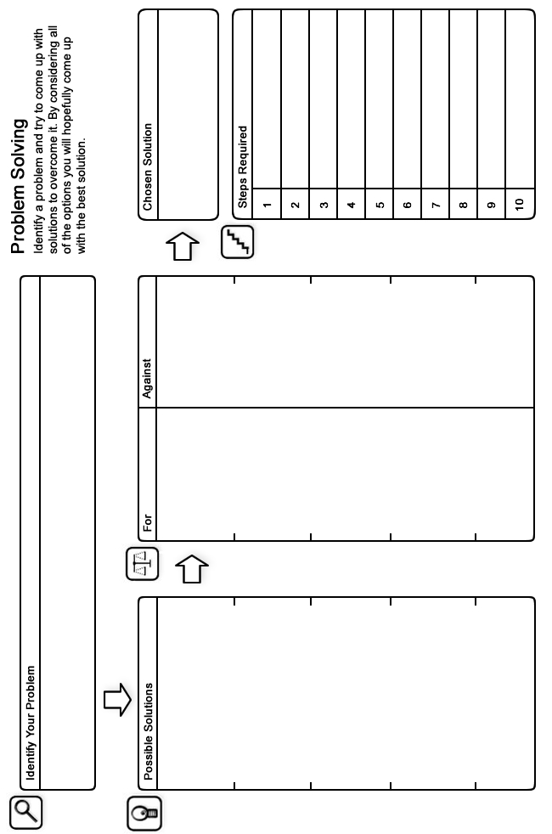

**Looking After Yourself**

Taking steps towards a healthy lifestyle can have a real impact on our stress levels. On the other hand, unhealthy habits can put your health, or the health of others, at risk. It can be a real challenge to overcome some habits or behaviours. Focusing on the benefits of positive change may boost your motivation.

**Alcohol**

Alcohol can impact your ability to cope and control behaviours. This can be unhelpful if you are trying to overcome problems with anger or anxiety. It can also interfere with your mood, and the quality of your sleep. You might think that consuming alcohol would help you sleep. In fact, as your body processes alcohol overnight it can wake you up. Some people use the numbing effect of alcohol to avoid thinking about or facing problems. Unfortunately, this approach can be damaging and make things worse. Drinking a lot and often can lead to a pattern of addictive substance misuse.

**Drugs**

Many drugs have a sedative or stimulant effect on the body which can have an impact on your sleep and mood. Some people use recreational drugs as a distraction, to avoid thinking about or facing problems. Using such substances can be damaging anWineglassicon.jpgdrugicon.jpgsmokingicon.jpgmugicon.jpg2peopleicon.jpgKnife&forkicon.jpgd make things worse. Developing a habit of regular or increasing use can lead to a pattern of addictive substance misuse.

**Smoking**

The content of cigarette smoke and nicotine replacements act as a stimulant. This can have an impact on your sleep and your mood. Some people say that smoking helps them to cope with stress. Smoking is known to have a negative impact on long-term physical health.

**Caffeine**

Caffeine can trigger a reaction that is similar to the symptoms of anxiety. It can also reduce the quality of sleep. It is best not to have anything caffeinated within four hours of bedtime. Coffee, tea, hot chocolate, energy drinks, and some fizzy drinks contain caffeine. By cutting down or stopping your consumption of potentially harmful substances, you are taking steps towards a healthier lifestyle.

**Relationships / Social Network**

Good relationships and support from friends and family can really help us cope better. It can also mean that we overcome problems more quickly and for longer. It can be really helpful to talk through difficulties with friends. You could discuss ways of coping, and some of them might have been through something similar.

**Healthy Eating**

What you eat and drink can have a significant impact on both your mood, sleep and physical health. Consider making changes towards having a balanced, nutritious diet. Try to eat regular meals and stay hydrated. Avoid unhealthy food that contain a lot of fat or sugar. Also, consider what you eat and drink close to bedtime. Caffeine, alcohol or a large meal can interfere with your sleep.

**Exercise**

Keeping fit and active can improve your physical health, mood and ability to cope with problems. Try to get at least some gentle exercise each week. You could try going for a walk, doing the garden or housework, playing sport or joining an exercise class. While exercise can also help us sleep, try not to be too active close to bedtime as this can keep you awake.

**Routine**

Having a consistent routine can help give structure to your life. Patterns can be set as we react the same way or do the same thing in certain situations. Our body can begin to expect and follow such routines. For example, taking time to relax and unwind before bed, and getting up at the same time.

**Surroundings**

Notice the impact of your environment on your mood. Consider the noise, temperature and light that you have to deal with. Your comfort and the tidiness of your surroTennisracketicon.jpgClockicon.jpgTreeicon.jpgundings can all have an impact on your mood. It can also effect your sleep and your overall ability to cope with problems. Try to take practical steps to resolve any particular issues.

Now you have some ideas to inspire healthy changes to your lifestyle, why not try them out? You could ask a friend for support. If you build them into your daily routine they won't seem like such a chore. Before long you might forget you ever did anything different!

**Final Word**

We hope that you found some of the ideas in this booklet useful. You can continue to use the techniques you found helpful long into the future and they should continue to benefit you. If some of the ideas are not particularly helpful at first, it is perhaps worth sticking with them for a few weeks to give them a chance to work. If however you feel your situation remains largely unchanged or if you did not find this booklet useful, you should speak to your GP who can tell you about the other options available which you could find helpful.

**Some Useful Organisations**

The following organisations or services may be able to offer support, information and advice.

**Northumberland, Tyne and Wear NHS Foundation Trust**   
Website for information and self help leaflets on mental health.

*Web Site:* <http://www.ntw.nhs.uk/pic/>

**edspace**   
Welcome to the edspace online information service Who this site is for: People experiencing mental health difficulties Carers, family and friends of people experiencing mental health difficulties Employees of service providers across the statutory, voluntary and private sectors Anyone with an interest in mental health and wellbeing

*Web Site:* <http://www.edspace.org.uk/>

**Samaritans**   
Samaritans provides confidential emotional support, 24 hours a day for people who are experiencing feelings of distress or despair, including those which may lead to suicide. You don't have to be suicidal to call us. We are here for you if you're worried about something, feel upset or confused, or you just want to talk to someone.

*Phone:* **08457 90 90 90**

*Web Site:* <http://www.samaritans.org>

**National Debt Line**   
National Debtline is a national telephone helpline for people with debt problems in England, Wales and Scotland. Our service is free, confidential and independent.

*Phone:* **0808 808 4000**

*Web Site:* <http://www.nationaldebtline.co.uk/scotland/>

**midspace**   
Welcome to the midspace mental health and wellbeing information service. Who this site is for: People experiencing mental health difficulties Carers, family and friends of people experiencing mental health difficulties Employees of service providers across the statutory, voluntary and private sectors Anyone with an interest in mental health and wellbeing

*Web Site:* <http://www.midspace.co.uk>

**Edinburgh Crisis Centre**   
24 hour helpline for those with mental health difficulties We can support you to deal with difficult feelings or thoughts you may be experiencing during a time of crisis. We are an inclusive service and offer support to all people. We have developed extensive resources with information for people who may have specific needs relating to culture, disability, gender, race and sexuality.

*Phone:* **0808 801 0414. Text 07974429075**

*Web Site:* <http://www.edinburghcrisiscentre.org.uk/wordpress/>

**Cruse Bereavement Care Scotland**   
Cruse Bereavement Care Scotland is a national organisation which offers a free confidential bereavement counselling service to people of all ages.

*Phone:* **0845 600 2227**

*Web Site:* http://www.crusescotland.org.uk

**The Centre for Clinical Interventions (CCI)**   
For free workbooks and resources for varied mental health issues.

*Web Site:* <http://www.cci.health.wa.gov.au/about/index.cfm>

**Couple Counselling Lothian**   
Couple Counselling Lothian offers counselling and a range of other services for couples and individuals, children, young people and extended families who are affected by relationship problems. As well as helping those who are thinking of staying together, separating or dealing with divorce, we see many people whose relationship has ended and who want to explore the issues around making new relationships. We will see you whether you are in a civil partnership, married, living together, in a less formal relationship, divorced or separated. Our service is available whatever your age, race, personal beliefs, sexual orientation or social background. As we offer a number of services, when you contact us, we ask you to complete a questionnaire so that we can recommend the right service for you.

*Phone:* **0131 556 1527**

*Web Site:* <http://www.cclothian.org.uk/>

**Breathing Space**   
Breathing Space is a free, confidential phone line you can call when you're feeling down. You might be worried about something - money, work, relationships, exams - or maybe you're just feeling fed up and can't put your finger on why.

*Phone:* **0800 83 85 87**

*Web Site:* <http://www.breathingspacescotland.co.uk>

**Orchard Centre Services**   
Health in Mind � Offers a wide range of information, support and activities for people with mental health problems.

*Phone:* **0131 225 8508**

*Web Site:* <http://www.health-in-mind.org.uk/services/orchard-centre-services.html>

**Living Life to the Full**   
Living Life to the Full is an online life skills course made up of several different modules designed to help develop key skills and tackle some of the problems we all face from time to time.

*Web Site:* <http://www.llttf.com/>

**CHANGES Community Health Project**   
Mental health and wellbeing service in East Lothian.

*Phone:* **0131 653 3977**

*Web Site:* [www.changeschp.org.uk/](http://www.changeschp.org.uk/)

**Steps for Stress**   
A simple guide to stressing less and enjoying life more.

*Web Site:* <http://www.stepsforstress.org/>

**Step Out - West Lothian**   
Self help group for people who experience Generalised Anxiety Disorder (GAD), panic with / without agoraphobia and social anxiety,

*Phone:* **01506 464 173**

**Steps**   
This site will tell you about all about mental health and give you some ideas on how best to tackle it. Our approach is called Cognitive-Behavioural Therapy (CBT). CBT has been shown to be an effective way to fight stress. It is not a miracle cure - it takes time and it takes effort. So make sure you set aside time each time to do the three stages.

*Web Site:* <http://www.glasgowsteps.com/>

**Further Reading**

The following books may be able to offer support, information and advice.

**How to Stop Worrying**   
A guide to making worry work for you, helping you to avoid stress and anxiety. The author sets out to teach how to understand fear and face the possibilities of life calmly.

*Author:* Frank Tallis  
*Published:* 2009

**How to Stop Worrying and Start Living**   
Worry affects everyone and descends with ease upon work, money, family life and relationships. This book offers practical strategies for breaking out of this destructive habit, before it breaks you. The author shows how worry has been conquered by thousands, some famous, but most just ordinary people, and offers practical suggestions for leading a more positive and enjoyable life.

*Author:* Dale Carnegie   
*Published:* 1993

**Managing Stress (Teach Yourself)**   
Stress can be detrimental to our health, relationships and performance. This practical guide to stress management advises on assessing and identifying stress, and on developing a personal plan for dealing with stress.

*Author:* Terry Looker  
*Published:* 2008