

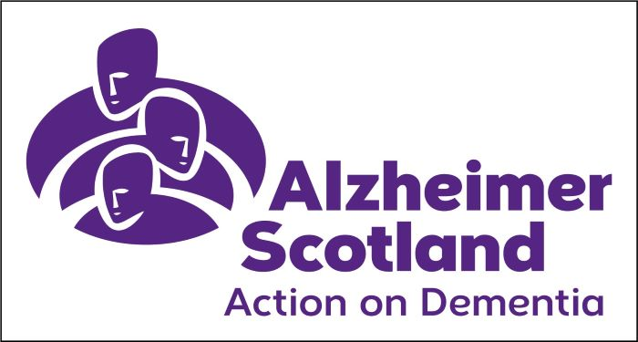



Herbert Protocol – Missing Person Form

The Herbert Protocol is an information gathering tool to assist the police to find a person, living with dementia who has been reported missing, as quickly as possible.

There may be important pieces of information that you are able to provide to the Police in the event that a relative or person you are caring for has gone missing. Try and have several copies of recent, close up photographs of the person, this will help the Police when they are searching for them.

The checklists below are indicative – do not worry if you don’t have, or cannot get, all of the information it asks for, some of it won’t apply to everyone.

It is a good idea to fill in this form after a diagnosis so you are prepared.

Please fill in these sections and keep the form in a safe place where it can be easily located if the person it refers to goes missing. You may want to make several copies which can be kept safe by neighbours or relatives. If you are concerned about the whereabouts of your friend / relative, then you must contact the police on 999. Please tell the call handler you have a Herbert Protocol Form.

This form is designed to be completed by a family member / care giver / friend or neighbour.

Part 1 (to be completed when it has been identified the individual is at risk of going missing, if the person is able they should assist in filling out the form)
Full name  (of person at risk) |  |  |  | Affix a recent photo here. It may also be helpful if you have an electronic photo which can be emailed to the police or added to the last page of this form. We can then send a copy to the officers mobile device.
Preferred name
Date of birth |  | Age
Race / ethnicity
Is English their first language? | Yes | No
If no, confirm language spoken
Current address
Postcode
Living at current address since:

General Description
Height, weight, build
Hair colour
Wig / hair piece? | Yes | No
Wears glasses? | Yes | No
Facial hair? | Yes | No
Any other identifying features
(e.g. tattoos, scars, etc.)

Access to Mobile Phone and Money
Does the person have access to a mobile phone? | Yes |  | No
If yes, what is the mobile number
Does the person know how to use their mobile phone? | Yes |  | No
Is there any GPS or “find my” facility set up on the phone? | Yes |  | No
If yes please provide details of person(s) who have access to GPS
Has the person got access to money? | Yes | No | Don’t know | If so, how much?

Previous addresses | 1.
Previous addresses | 2.
Previous addresses | 3.
Previous employment details and addresses | 1.
Previous employment details and addresses | 2.
Previous employment details and addresses | 3.
Places of interest or significance  (old school, favourite walk, church they attend, cemetery etc.) | 1.
 | 2.
 | 3.

Family / Friends / Contacts
Name | Address | Association | Phone number

If the person has been missing before where have they been found?

Weekly Habits and Routines
What regular routine do they follow? Someone visits? Weekly shop? Day café? Please include location / address where possible.
 | Morning | Afternoon | Evening
Monday
Tuesday
Wednesday
Thursday
Friday
Saturday
Sunday

Hobbies
(e.g. fishing, parks visited, etc.)

What Matters to Me
Who matters to me? Who can you talk to me about to comfort me?
What reduces my distress?
What is the best way to speak to me? (softly or loudly etc.)
Any other information which may be useful

Medical Information / Medical History / Dementia Diagnosis
Medical conditions, current medication, medical needs and times of medication can be added here if you feel this would be relevant if the person is missing. Please be aware of Data Protection requirements and confidentiality of medical data.
Medical conditions / medication
When was the diagnosis of dementia made?
Communication difficulties
Physical impairments
GP details

Details of the Person Completing this Form
Name
Relationship to person
Contact number
Date

Part 2 (to be completed when the person has been reported as missing)
Description of what the person was last seen wearing, include colour, designer labels / brands.
Shirt / sweater
Trousers / skirt
Outerwear (e.g. coat, jacket)

Headwear
Gloves
Scarf
Footwear
Jewellery
(e.g. watch, rings etc.)
Other
Does the person have their mobile phone with them at the time of going missing? | Yes |  | No
Has the person got any money with them? | Yes | No | Don’t know | If so, how much?

Does the person have a bus pass or train / subway pass? | Yes |  |  | No | Don’t know
How independent is the person at the time of going missing? How mobile are they? Do they use a walking aid?
Time, date and location last seen
Risk factors  (select all that apply) | Suicidal |  |  | Depressed |  | Confused
Risk factors  (select all that apply) | Alcohol |  |  | Violent / signs of frustration or confrontational when stressed
Other (please provide details below)
Completed on the date the person has gone missing by: (name)
Relationship to the missing person
Your contact number
Date
Any other relevant information

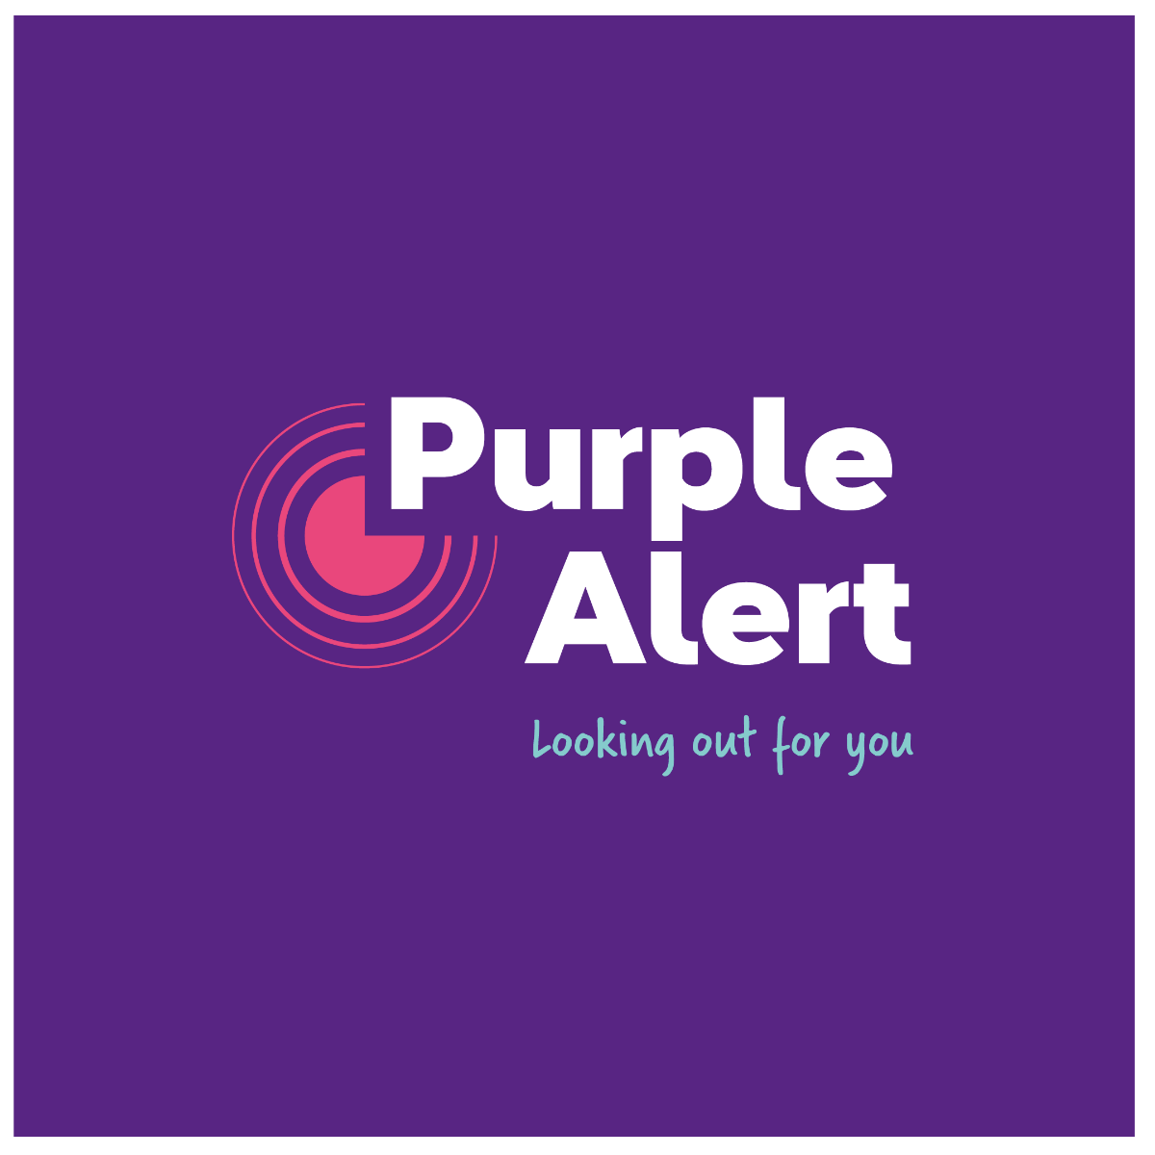
Purple Alert is a mobile app for people with dementia that allows the community to help if someone with dementia is missing.

The app allows the Main Carer to share information regarding the missing person at the point of crisis and allows for eyes and ears on the ground to immediately help with the search. The app was developed by Alzheimer Scotland and is free.
Has the Purple Alert App been downloaded? | Yes | No

Media Release Consent
1. As the individual named on this form have you had the conversation with your family or care giver and given prior consent to a media release in the eventuality you should be reported as a missing person? |  | Yes | No
2. Does the individual who is legal proxy (Power of Attorney or Guardian) for the individual named on this form give consent for a media release in the event that they are reported missing? |  | Yes | No
Name of legal proxy
Signature of legal proxy
Signature of individual
(if appropriate)
Date

Thank you for filling out this form.

Please keep this form as up to date as possible and review the content on a regular basis.

Please keep the form somewhere safe where it can be located quickly if the person concerned goes missing.

If you are concerned about the whereabouts of person named on this form and you believe them to be missing then you must contact the police on 999.

Information Regarding the Herbert Protocol Missing Person Form

The Herbert Protocol form should be completed by the individual(s) who knows the person named on the form best, who has the consent of the person concerned or power of attorney to do so.

The Herbert Protocol has been designed to allow you to complete the form in your own time or with the support of care professionals. A recent photo should also be kept with the form.

Why should I consider providing this information?

The information provided will assist Police enquiries in the event that the person concerned goes missing, so that they can be traced safe and well, as quickly as possible.

It is not a medical document, but will provide relevant information about the person at the time that the document is completed. We understand how stressful it can be answering questions from the Police when a relative or someone you care for has been reported missing so it covers some of the questions an officer would be required to ask if a person with dementia was reported missing.

Often people with dementia who go missing are found heading towards places which have a particular significance to them and it is important that any such places are highlighted on the form.

Don't worry if you can't complete the whole form. The more information you can provide, the better.

What will happen with this information?

You should be aware that information from this form will be recorded and assessed by officers on police systems in relation to enquiries carried out to trace the missing person. The form will only be used for a missing person enquiry and can be handed back to you or destroyed, whichever you prefer. Any photographs will be returned.

However, it is also important to highlight that sometimes, we must by law, share information with statutory agencies and we will share information in relation to a missing person incident with those agencies who have support, welfare or health responsibilities such as:

- Local Authority Health and Social Care, which includes Social Work Services;
- NHS Scotland; and
- Scottish Fire and Rescue Service (SFRS).

How does this comply with data protection law?

Police Scotland do not control the data on this form. When it becomes a Police incident (i.e. the person is reported missing), we will record this on to the relevant police systems. The information you provide will be processed on the basis of our public task and of substantial public interest in safeguarding, in accordance with the General Data Protection Regulations (GDPR) and the Data Protection Act 2018.

More information on how we handle personal data for these purposes is given in our Protection and Wellbeing Privacy Notice, available on our website https://www.scotland.police.uk/access-to-information/data-protection/privacy-notices/

Contacts / Further Information

Police Scotland www.scotland.police.uk

Alzheimer Scotland www.alzscot.org

Purple Alert www.purplealert.org

Health and Social Care Scotland www.hscscotland.scot

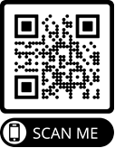
If you require access to further copies of this form or wish to visit the Police Scotland website, you can do so by scanning this QR code:

Photographs can be copied and pasted into the box below:

