Guided Self Help – What to Expect.

Why guided self-help?

Many people experience problems such as depression, anxiety and stress. Often people struggle on, hoping that things will improve with time. Sometimes they do! But all too often problems like depression, stress and anxiety, and the way we try to cope with them, can become a negative spiral.

Example:
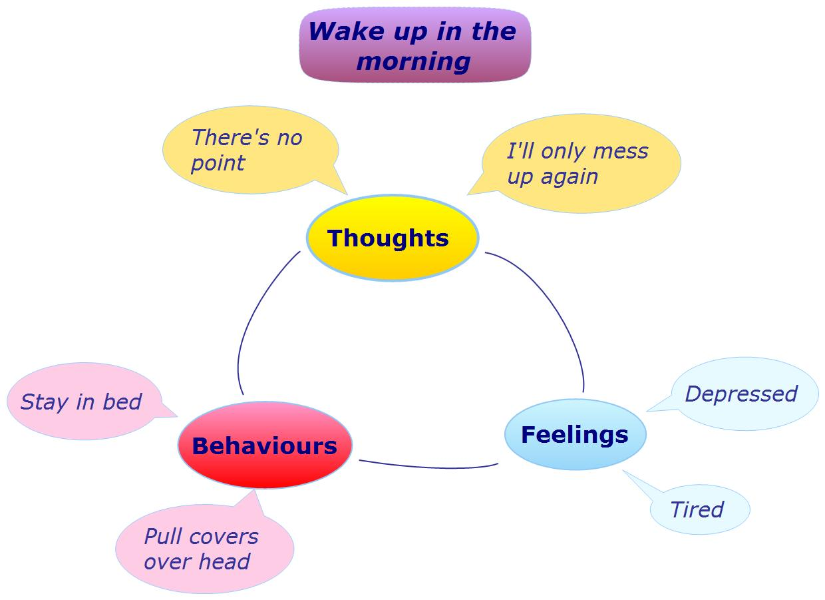
Guided self-help can help you break out of the negative spirals and overcome feelings of low mood and anxiety.

What is guided self-help?

Guided self-help (GSH) is a supportive approach for people who are experiencing symptoms of mild to moderate depression, stress and other related difficulties. GSH is based on a cognitive behavioural therapy (CBT) approach. Clients work through self-help materials relevant to their specific problem on their own, with the guidance of a worker. Your worker will help you in selecting which materials will be of most benefit to you. The explanations and tasks in the workbooks can help you to understand what you are experiencing and learn ways to make changes for the better. GSH is not a traditional ‘talking therapy’, as the majority of the work will be done on your own, however the GSH worker can provide guidance on using the materials and help you problem solve any issues you are having with them.

GSH is four sessions. Your first session will last about 50 minutes, during which time your worker will discuss your circumstances and complete an assessment questionnaire to ensure guided self-help is the right approach for you. Your worker will then introduce you to the materials which you will be using over the next three sessions. Follow up sessions last between 30-45 minutes, and are usually scheduled a couple of weeks apart.
Who is guided self-help suitable for?

It is suitable for people of all ages and backgrounds who are experiencing depression, anxiety, stress and other related difficulties, and are motivated to change. People must be prepared and motivated to try and identify, challenge and make changes to existing behaviours and thoughts that they hold, which are contributing to their situation. GSH does require homework and working through materials in your own time.

What clients have said about guided self-help
“The workbooks really helped me to understand depression. Some things I tried worked first time. The harder things like building relationships took time.”
“I found the self help approach really useful in understanding what I was going through and would highly recommend it.”
“It was nice for someone to take the time to listen to me and understand what I was going through”

Confidentiality

Any information that you discuss will be treated as confidential, unless it is felt that you or others might be in danger. At the end of your guided self-help sessions your worker will send a short letter to your GP to let them know how you have been getting on with guided self-help. A copy of this letter can also be sent to you.

To make your first appointment

To find out more about guided self-help please get in touch with us. Our Guided self-help workers can meet you at a variety of locations across Edinburgh.

Please call us on 0131 2258508.

We look forward to hearing from you.

